**CLASS ALPHAPROTEOBACTERIA**

**Alphaproteobacteria** is a class of bacteria in the phylum Pseudomonadota. It is one of the five major classes of Proteobacteria and is characterized by a diverse range of metabolic capabilities, ecological niches, and symbiotic or pathogenic relationships.

**ALPHAPROTEOBACTERIA CHARACTERISTICS**

* **Range of cell shapes**: rods, cocci, and spiral forms
* They are Gram-negative
* Typically reproduce via binary fission
* Aerobic, anaerobic, facultative anaerobes, and Phtosynthetic
* 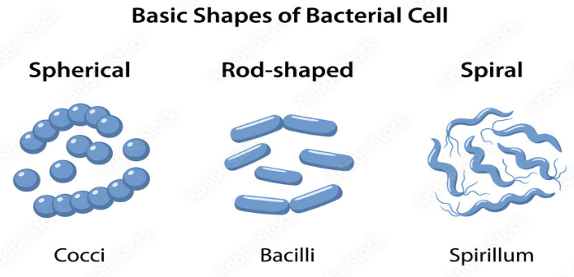Motile and Non-motile

**Where Alphaproteobacteria can be found?**

* Soil - Alphaproteobacteria are abundant in soils, playing a crucial roles in nutrient cycling and plant growth.
* Aquatic Environments - Alphaproteobacteria are found in various aquatic habitats including freshwater lakes, rivers, and oceans.
* Extreme Environments - Alphaproteobacteria can even be found in extreme environments, such as hot springs, glaciers, and deep-sea vents.
* Inside Other Organisms - Some alphaproteobacteria are intracellular pathogens, meaning they live inside the cells of other organisms.

ALPHAPROTEOBACTERIA ORDER

1. Rickettsiales - are mostly obligate intracellular pathogens that infect humans, other mammals, and arthropods.
2. Rhizobiales - this order includes nitrogen-fixing bacteria that form symbiotic relationships with leguminous plants (e.g., beans, peas, clover).
3. Caulobacterales - these bacteria are commonly found in aquatic environments and they have specialized structures like stalks or prosthecae that help with nutrient acquisition and attachment to surfaces.
4. Sphingomonadales - These bacteria are known for their ability to degrade complex organic compounds, including pollutants such as xenobiotics (e.g., aromatic compounds, pesticides).

5. Rhodobacterales - this order contains photosynthetic bacteria that can perform both aerobic and anaerobic photosynthesis.

6. Methylobacteriales - these bacteria are methylotrophs, meaning they can metabolize methanol or other one-carbon compounds as their primary carbon and energy sources.

7. Brucellales - this order includes intracellular pathogens, with Brucella being responsible for the disease brucellosis, which can infect humans and a variety of domestic and wild animals.

**Nitrogen Fixation**

the process by which certain species of these bacteria convert atmospheric nitrogen (N₂), which is biologically inert and unavailable to most organisms, into ammonia (NH₃) or other nitrogenous compounds that plants and other organisms can use for growth. This process is essential for the nitrogen cycle, as it replenishes the soil with usable nitrogen, an essential nutrient for plant and microbial life.

**IMPACTS OF ALPHAPROTEOBACTERIA ON HUMAN HEALTH**

Some members of Rickettsiales order are responsible for causing diseases such as Rocky Mountain spotted Fever and Typhus.

1. **Rocky Mountain Spotted Fever** -a bacterial disease spread by ticks. It typically begins with a fever and headache, which is followed a few days later with the development of a rash. The rash is generally made up of small spots of bleeding and starts on the wrists and ankles.
2. **Typhus Fever** - a group of bacterial illnesses that cause similar symptoms, like high fever, chills, rash, body aches, cough, digestive issues and confusion. Types include murine (endemic) typhus, epidemic typhus and scrub typhus. You get typhus from fleas, lice or chiggers.

**Brucellales** are responsible for Brucellosis in humans and animals.

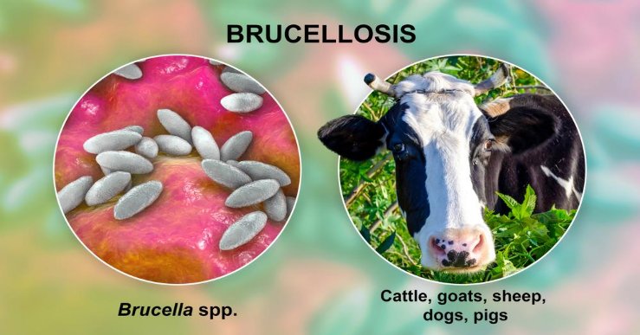**Brucellosis** - a bacterial disease caused by various Brucella species, which mainly infect cattle, swine, goats, sheep and dogs. Humans generally acquire the disease through direct contact with infected animals, by eating or drinking contaminated animal products or by inhaling airborne agents.

Some species, such as those in Rhizobales order, have been used in Bioremediation to clean up pollutants in the environment.

**Bioremediation** - a natural process that uses microorganisms to clean up contaminated soil and water. It's an eco-friendly, cost-effective, and safe method for removing contaminants like heavy metals, pathogens, and volatile organic compounds

**Agrobacterioum** is a genus of bacteria known for its ability to transfer genetic material, known as the plasmids, into the DNA of plants, causing tumors and other diseases. However, this unique ability has also been harnessed for genetic engineering in agriculture allowing scientists to introduce desirable traits into plants.

**CLASS BETAPROTEOBACTERIA**

The Betaproteobacteria are one of the eight classes that make up the "**Proteobacteria**".

BETAPROTEOBACTERIA- is a class of Proteobacteria that are all Gram-negative.

Aerobic Bacteria - are the bacteria that survive and grow only in the presence of oxygen in their environment.

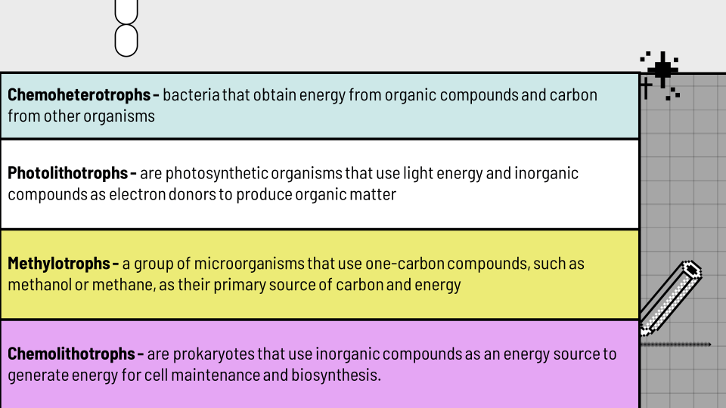Facultative Bacteria - a type of bacteria that can survive and grow in both the presence and absence of oxygen.

genera with important pathogens:

* ORDER NEISSERIALES
* ORDER BURKHOLDERIALES
* ORDER NITROSOMONADALES
* ORDER HYDROGENOPHILALES

**Order Neisseriales**

* family Neisseriaceace (with 15 genera)
* most studied genus is Neisseria
* are nonmotile, aerobic, gram-negative cocci usually seen in pairs with the adjacent sides flattened
* may have capsules and fimbriae
* chemoorganotrophic - organisms that use chemical energy from organic compounds as their energy source
* the genus is best known for the diseases it causes: meningitis and gonorrhea

**MENINGOCOCCAL MENINGITIS**

**Meningitis** is an inflammation of the brain or spinal cord meninges (membrane).

* It's caused by the bacteria Neisseria meningitidis, also known as meningococcus
* It can be divided into:
* **bacterial (septic) meningitis** - can be diagnosed by a Gram stain and culture of bacteria from cerebral spinal fluid.
* **aseptic meningitis syndrome** - some causative agents can be treated with antimicrobial agents
* symptoms: fever, headache, stiff neck, photophobia, nausea, vomiting, diarrhea, purpura or petechiae.

**GONORRHEA**

* **Gonorrhea** is an acute, infectious, sexually transmitted disease of the mucous membranes of the genitourinary tract, eye, rectum, and throat caused by N. gonorrhoeae.
* These bacteria are also referred to as **gonococci** and have a worlwide distribution.
* You get an infection when the bacteria that causes gonorrhea (N. gonorrhoeae) enters your body through sexual fluids, like semen or vaginal fluid — often through unprotected sex.
* In males, the incubation period is 2 to 8 days.
* The onset consists of a urethral discharge ofyellow, creamy pus, and frequent, painful urination that is accompanied by a burning sensation.
* In females, the cervix is the principal site infected. The disease is more insidious in females and few are aware of any symptoms.
* Some symptoms may begin 7 to 21 days after infection.
* Are generally mild; some vaginal discharge may occur.
* **Pelvic inflammatory disease (PID)**
* **Opthalmia neonatorum, or conjunctivitis of the newborn.**

**Order Burkholderiales**

* The order Burkholderiales contains four families.
* **Burkholderia** was established when Pseudomonas was divided into at least seven genera based on rRNA data: **Acidovorax, Aminobacter, Burkholderia, Comamonas, Deleya, Hydrogenophaga,** and **Methylobacterium**
* Are gram-negative, aerobic, nonfermentative, nonsporing, mesophilic straight rods
* All are motile with a single polar flagellum except one species
* Use poly-beta-hydroxybutyrate (PHB) as their carbon reserve
* **B. cepacia, B. mallai, B. pseudomallei**, are human pathogens that could be misused as bioterrorism agents
* Burkholderia and Ralstonia isolates reveals the presence of nodulation genes that are very similar to those of the rhizobia.
* Some members of the order Burkholderiales have a **sheath**—a hollow, tubelike structure surrounding a chain of cells.
* Sheaths help bacteria attach to solid surfaces and acquire nutrients from slowly running water as it flows past, even if it is nutrient-poor.
* Sheaths also protect against predators such as protozoa.
* Family **Alcaligenaceae** contains the genus Bordetella
* composed of gram-negative, aerobic coccobacilli, about 0.2 to 0.5 µm by 0.5 to 2.0 µm in size.
* Bordetella is a **chemoorganotroph** with respiratory metabolism that requires organic sulfur and nitrogen (amino acids) for growth
* multiplies in respiratory epithelial cells.
* **B. bronchiseptica, B. pertussis,** and **B. parapertussis**

**Pertussis**

* Pertussis (Latin per, intensive, and hussis, cough)
* "whooping cough,"
* characterized by fever, malaise, uncontrollable cough, and cyanosis
* highly contagious
* transmission occurs by inhalation of the bacterium in droplets released from an infectious person
* the incubation period is 7 to 14 days.
* Three stages of Pertussis:
* the catarrhal stage
* the paroxysmal stage
* the convalescent

**Order Nitrosomonadales**

A number of **chemolithotrophs** are found in the order Nitrosomonadales. Two genera of nitrifying bacteria (Nitrosomonas and Nitrosospira) are members of the family Nitrosomonadaceae but were discussed earlier with other genera of nitrifying bacteria. The stalked chemolithotroph Gallionella is in this order. The family Spirillaceae has one genus, Spirillum.

**Order Hydrogenophilales**

This small order contains Thiobacillus, one of the best-studied chemolithotrophs and most prominent of the colorless sulfur bacteria. Like the nitrifying bacteria, colorless sulfur bacteria are a highly diverse group. Many are unicellular rod-shaped or spiral, sulfur-oxidizing bacteria that can be either nonmotile or flagellated.

**Maverick PLANCTOMYCETES**

**HISTORY**

**•** Planctomyces bekefii (Nador Gimesi-1924)

- Lake Lagymanyos in Budapest, Hungary

- threadlike forms which bore spherical structures

- floated in the euthrophic waters.

- cryptic morphology

- described as a fungus

• Blastocaulis sphaerica (Henrici & Johnson -1935)

- Lake Alexander, Minnesota, U.S.A.

- stalked budding microorganism

New Description and Conclusive Evidence

• Peter Hirsch (1972)

- Planctomyces bekefii & Blastocaulis sphaerica were indistinguishable, being both bacteria rather than fungi.

**Confusing Etymology of Planctomycetes**

Planktos – wandering, floating

Mukés or mykés – fungus

• Planctomyces bekefii – priority was given to this name

• Blastocaulis sphaerica – subjective synonym

**PLANCTOMYCETES** are ubiquitous bacteria, notable for their complex cellular structures.  
  
- found in freshwater, seawater, and terrestrial environments (Wiegand et al., 2018).

- they can live freely and can adhere to biotic and abioticsurfaces.  
 - slow growing, recalcitrant and refractory.

**PHYLUM PLANCTOMYCETES**

**Class**: Planctomycetia

**Order**: Planctomycetales

**Family**:

Planctomycetaceae

Isosphaeraceae

Gemmataceae

**Class**: Phycisphaerae

**Order**:

Phycisphaerales

Tepidisphaerales

**Family**: Tepidisphaeraceae

**Genus**:

Tepidisphaera

**Family**: Phycisphaeraceae

**Genus**:

Algisphaera

Phycisphaera

**PLANCTOMYCETES STRUCTURES**

• Holdfasts/Stalks: These are appendages that anchor the cells to substrates, allowing them to remain in place while they grow and reproduce.

• Crateriform Structures: Some Planctomycetes also possess crateriform structures on their surface, which may assist in adhesion and interaction with their environment.

**Classic Perspective** (Lindsay et al., 2001)

• Proteinaceous cell wall

• Compartmentalize cytosol

- paryphoplasm

- pirellulosome

**Recent Discovery** (Boedeker et al., 2017)

• Peptidoglycan cell wall

• Cytoplasmic membrane

- is the “Outer membrane “

• Intracytoplasmic membrane

- is the “Cytoplasmic membrane “

• Large invagination

- of the cytoplasmic membrane

• Exceptional Gram - negative bacteria

- the cells display an exceptionally “Enlarged Periplasmic Space.”

**PLANCTOMYCETES REPRODUCTION PROCESS**

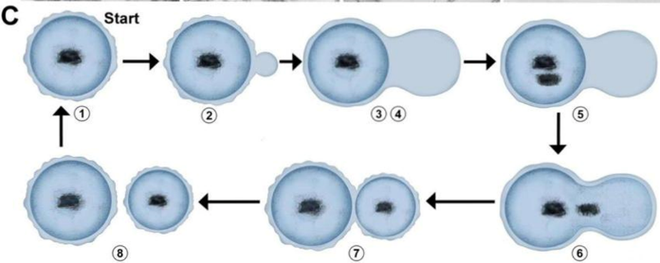

**• Polar budding**

- this is a type of asexual reproduction where a new cell, called a bud, forms at one specific point on the parent cell. The bud grows and eventually separates from the mother cell.

• **FtsZ** – less binary fission

- Unlike most bacteria that rely on the FtsZ protein for division, Planctomycetes do not have FtsZ, indicating a fundamentally different mechanism of binary fission.

**Sample Species**

• **Isophaera pallida**

- Moderate thermophile

- Inhabits thermal springs

- Lives in oxygen saturated water with exposure to high solar radiation levels

- Contains carotenoids even though it is not phototrophic. Believed that it helps the bacteria align itself with the radiation.

**Maverick**   
- due to their unique characteristics that challenge traditional classifications of bacteria.

**CLASS EPSILONPROTEOBACTERIA**

**Definition:**

* Epsilonproteobacteria represent a distinct class within phylum Proteobacteria.
* Smallest of the validly five proteobacterial classes.
* Characterized by unique rRNA signatures and marker genes, differentiating them from other proteobacterial classes.

Etymology: The term “Epsilonproteobacteria” is derived from the Greek letter epsilon (ε), which is the fifth letter in the Greek alphabet.

History of Discovery: Epsilonproteobacteria was first described in the early 1990s, formally recognized as the fifth subclass of the Proteobacteria.

**Taxonomic Details**:

* One order: Campylobacterales
* Three families: Campylobacteraceae, Helicobacteraceae, and Nautiliaceae.

Pathogenic Genera: Contains pathogenic genera such as Campylobacter and Helicobacter.

**Phylogenetic Relationships:**

* Occupy a specific clade, showing an evolutionary path marked by significant diversification.
* Often found in extreme environments, such as hydrothermal vents and acidic hot springs.
* Compact genome sizes, with high gene density and minimal non-coding sequences, reflecting adaptation to specific niches.

**Morphological and Physiological Characteristics:**

Cellular Structure:

* Slender Gram-negative rods.
* Can be straight, spiral, or helical.
* Single, often polar flagellum for motility.

Growth Requirements:

* Microaerophilic
* Thrive in extreme conditions
* Temperature preferences vary (including thermophilic species).

Metabolic Diversity:

* Chemolithotrophic and chemoorganotrophic growth.
* Utilize various electron donors for energy production: Hydrogen, Reduced sulfur compounds, Organic substrates.
* Strong urease production (especially in Helicobacter).

Nutritional Strategies:

* Chemolithotrophy
* Fermentative pathways
* Syntrophic interactions

**1. Campylobacter**

Pathogenicity:

* C. jejuni causes approximately 2 million cases of gastroenteritis annually in the US.
* Transmission through:
* Contaminated food and water.
* Contact with infected animals.
* Sexual activity.
* Symptoms include diarrhea, fever, and inflammation.
* Linked to Guillain-Barre syndrome.

Other Species:

* Campylobacter fetus causes reproductive disease in cattle and sheep.

**2. Helicobacter**

Pathogenicity:

* H. pylori is a major human pathogen.
* Causes gastritis and peptic ulcer disease.
* Classified as a Class I carcinogen.

Infection rates:

* 70–90% in developing countries.
* 25–50% in developed countries.

Survival mechanisms include:

* Urease production.
* Mucous layer colonization.
* Multiple virulence factors.

**3. Wolinella**

Characteristics: Curved to spiral rods primarily found in the digestive systems of animals.

**4. Sulfurospirillum**

Characteristics: Notable for its hydrogen-producing capabilities during fermentation processes.

**Transmission to Humans**

* Primarily transmitted via contaminated food, water, or direct contact with infected animals.
* Campylobacter infections often result from consumption of undercooked poultry.
* Helicobacter pylori can be transmitted through contaminated food, water, or person-to-person contact.

**Transmission to Animals**

Campylobacter fetus: Can infect livestock, particularly cattle and sheep, causing miscarriages and other reproductive health issues. Transmission typically occurs through direct contact with infected animals or contaminated water or feed.

**Treatment and Prevention**

For Campylobacter:

* Supportive treatment.
* Fluid replacement.
* Erythromycin for severe cases.
* Prevention through hygiene and food safety.

For H. pylori:

* Two-pronged approach:
* Acid-reducing drugs.
* Antibiotics.
* Complete elimination as the treatment goal.

**Wolinella**

Serves as a symbiont in the digestive systems of ruminants, contributing to digestion and nutrient processing.

**Sulfurospirillum**

Involved in sulfur cycling in anoxic environments and hydrogen production during fermentation.